**Ideation Phase**

**Define the Problem Statements**

|  |  |
| --- | --- |
| Date | 19 September 2022 |
| Team ID | PNT2022TMID30874 |
| Project Name | Intelligent vehicle damage and cost estimator |
| Maximum Marks | 2 Marks |

**Example:**

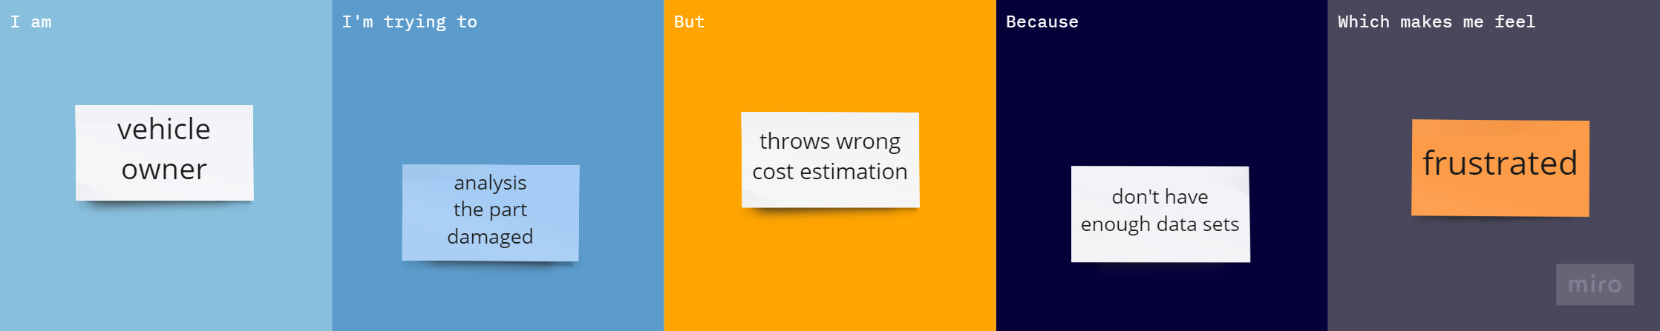

|  |  |  |  |  |  |
| --- | --- | --- | --- | --- | --- |
| **Problem Statement (PS)** | **I am (Customer)** | **I’m trying to** | **But** | **Because** | **Which makes me feel** |
| PS-1 | Vehicle Owner | Analysis the part damage | All the time I could not find exact cost | There is not enough data sets about damage parts | Worry about customer  Satisfaction |
| PS-2 | Vehicle Owner | Getting more data about the damage parts | We don’t have enough data sets | Good software and test data are needed | bad |